AWS Lambda & API Gateway Task

Overall Tasks Objective:
To design and implement a serverless application using AWS services by creating and configuring an AWS Lambda function, integrating it with Amazon S3 and Amazon API Gateway, exposing the function through multiple invocation methods, and monitoring execution using Amazon CloudWatch. The objective is to demonstrate an end-to-end serverless workflow without managing servers while ensuring scalability, reliability, and observability.
Overall Prerequisites:
• Active AWS account
• IAM permissions to create and manage:
• AWS Lambda functions
• API Gateway HTTP APIs
• Amazon S3 buckets
• CloudWatch logs
• Basic knowledge of Python
• Understanding of serverless and event-driven architecture
• Familiarity with AWS Management Console

Task Title:
AWS Lambda Implementation with S3 Trigger, Function URL, and CloudWatch Logging
Objective:
To design and implement an AWS Lambda function using a serverless architecture, validate its execution through test events, integrate it with Amazon S3 for event-driven invocation, expose the function using a public Function URL, and monitor execution logs using Amazon CloudWatch.
Prerequisites:
• Active AWS account
• Access to AWS Management Console
• IAM permissions to:
• Create and manage AWS Lambda functions
• Create IAM roles and attach policies
• Write logs to Amazon CloudWatch
• Basic knowledge of Python programming
• Understanding of serverless computing concepts
• Internet access to test Lambda Function URL and API responses

Step 1: Access AWS Lambda Service
• Logged in to the AWS Management Console
• Used the search bar to navigate to AWS Lambda
• Opened the Lambda service dashboard
• Reviewed the Lambda introduction page explaining serverless execution
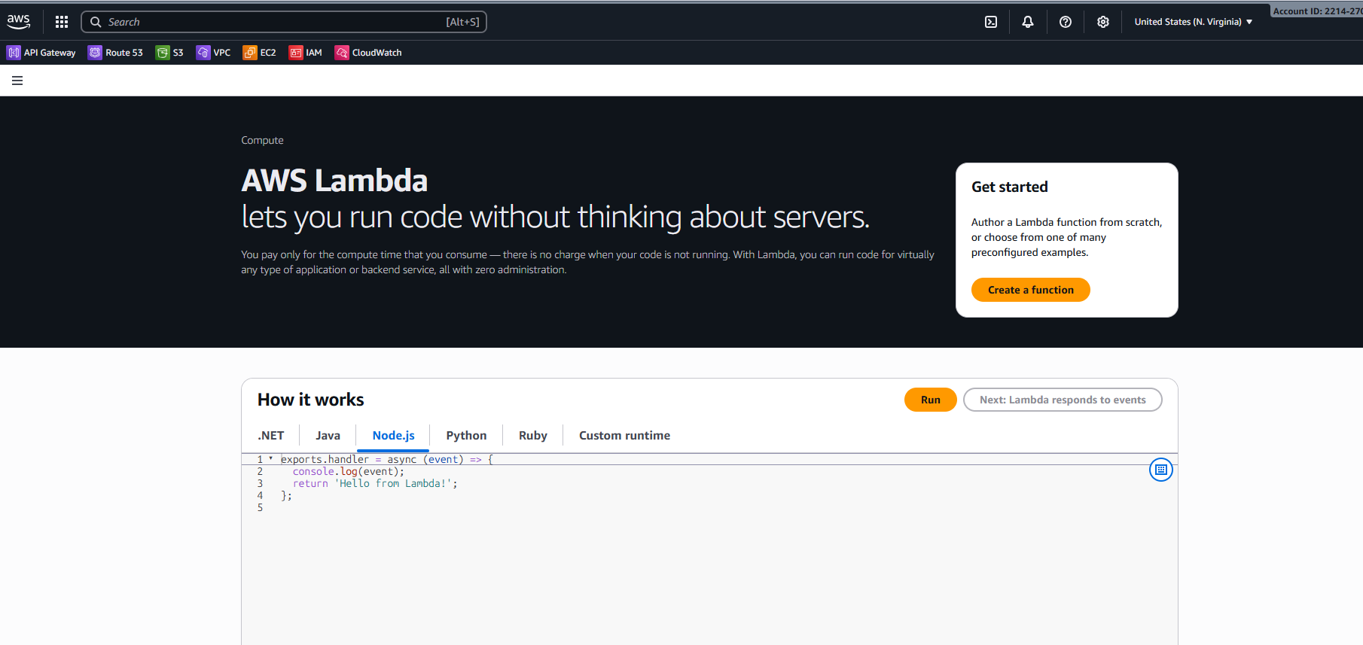

Step 2: Initiate Lambda Function Creation
• Clicked on Create a function
• Selected Author from scratch option
• This option allows writing custom Lambda code without templates or containers
Step 3: Configure Basic Lambda Function Details
• Entered function name as lambdatask
• Selected runtime as Python 3.14
• Python runtime allows writing event-driven serverless functions
• Selected architecture x86_64
• Architecture defines the CPU type Lambda will use during execution

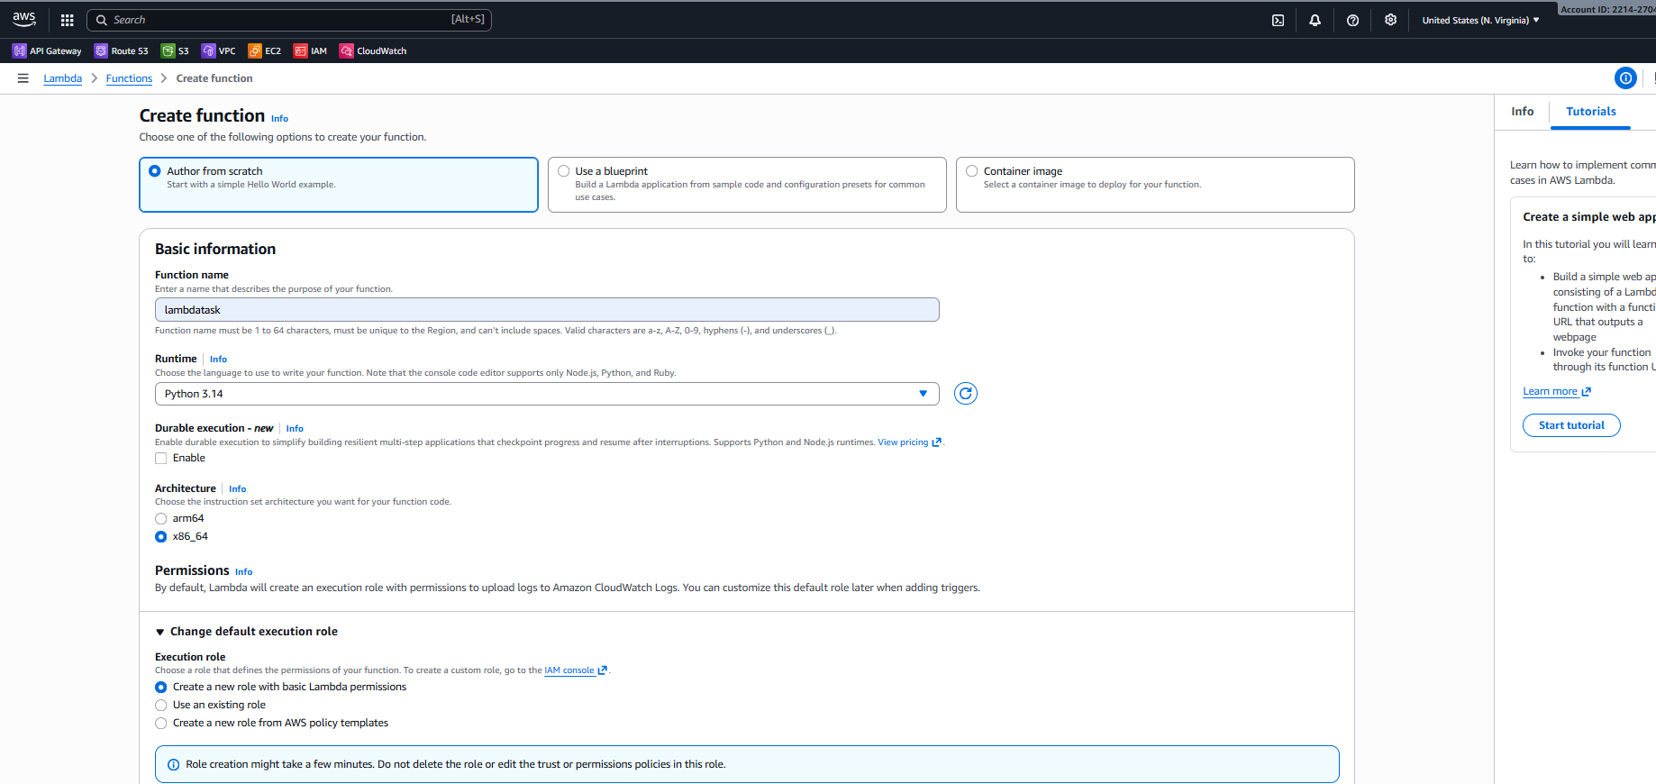
Step 4: Configure Execution Role (IAM Role)
• Chose Create a new role with basic Lambda permissions
• AWS automatically created an IAM role
• Role includes permission to:
• Create CloudWatch log groups
• Create log streams
• Push logs to CloudWatch
Step 5: Review Additional Lambda Configurations
• Compute type kept as Lambda default (serverless)
• Function URL not enabled at this stage
• VPC configuration left disabled
• Security and governance options left as default
• Tags not added
• Proceeded without changing advanced settings

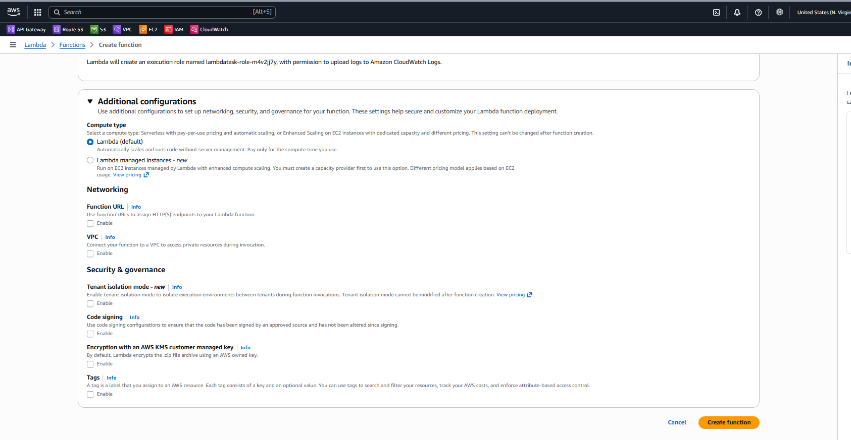
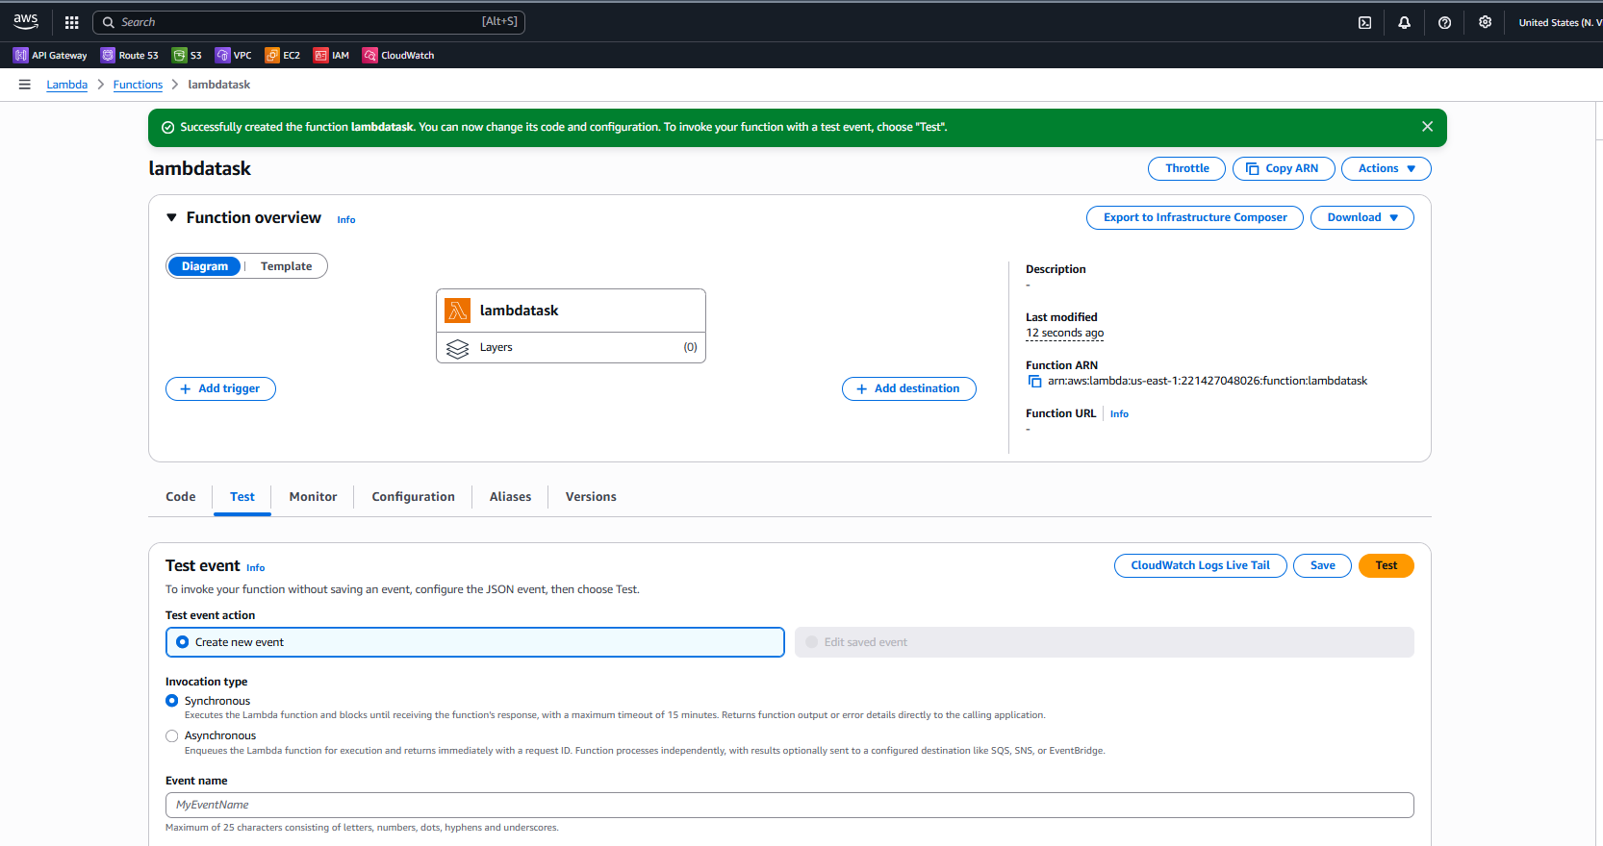
Step 6: Create Lambda Function
• Clicked Create function
• Lambda provisioned:
• Function resource
• Execution role
• Default handler file (lambda_function.py)
• Function creation completed successfully
Step 7: Review Lambda Function Overview
• Opened function overview page
• Observed Lambda diagram showing:
• Lambda function
• Layers section (empty)
• Verified function ARN was generated
• Confirmed function status is active
Step 8: Open Lambda Test Configuration
• Navigated to Test tab
• Selected Create new event
• Test events simulate how Lambda receives input from triggers

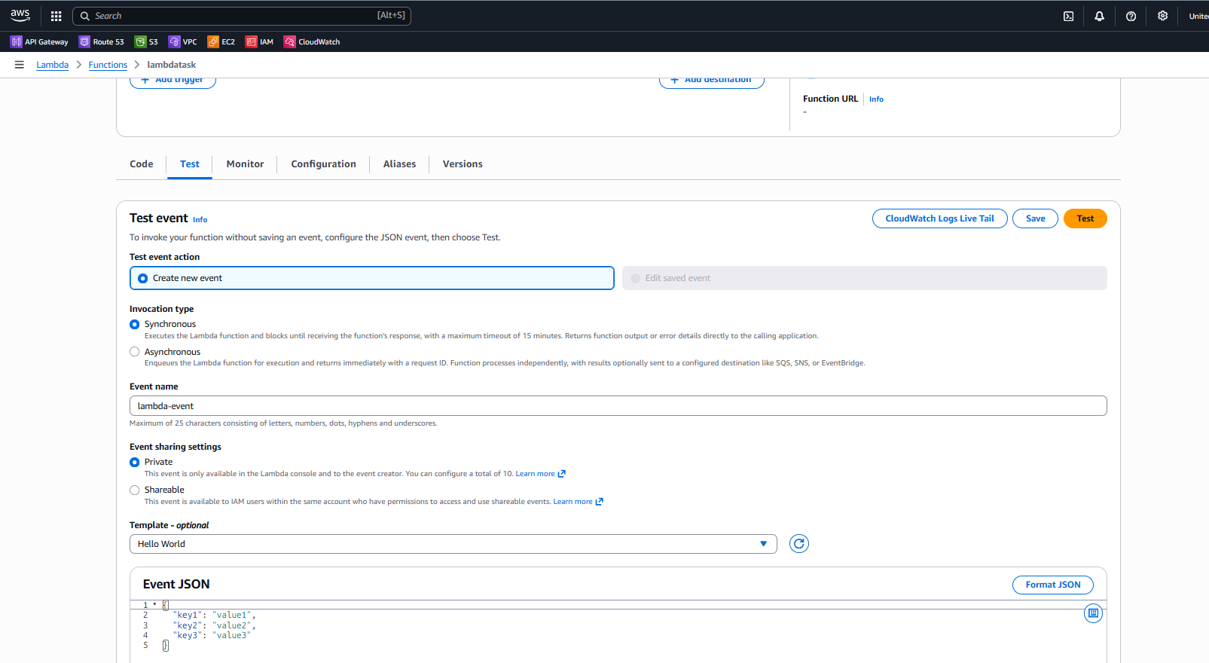
Step 9: Configure Test Event
• Entered test event name
• Selected Hello World template
• Default JSON payload retained
• Event sharing set to Private
• Saved the test event

Step 10: Execute Lambda Function (Initial Test)
• Clicked Test button
• Lambda function executed synchronously
• Execution succeeded
• Response displayed:
• HTTP status code
• Response body message
• Execution summary displayed:
• Duration
• Memory usage
• Request ID

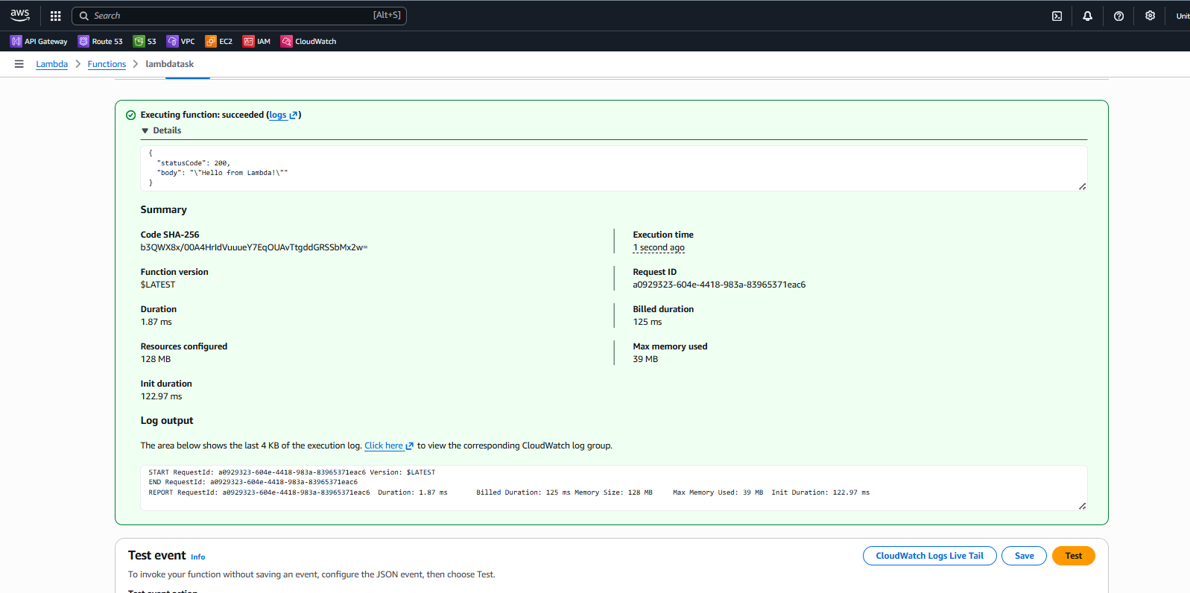
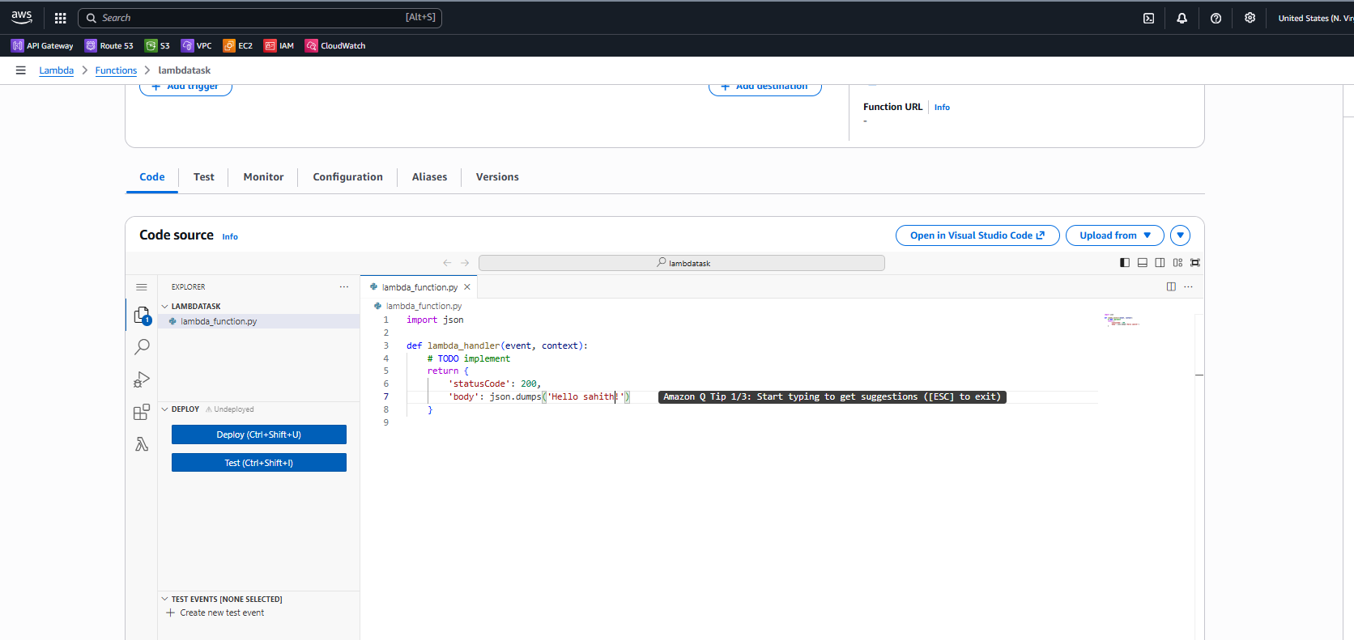
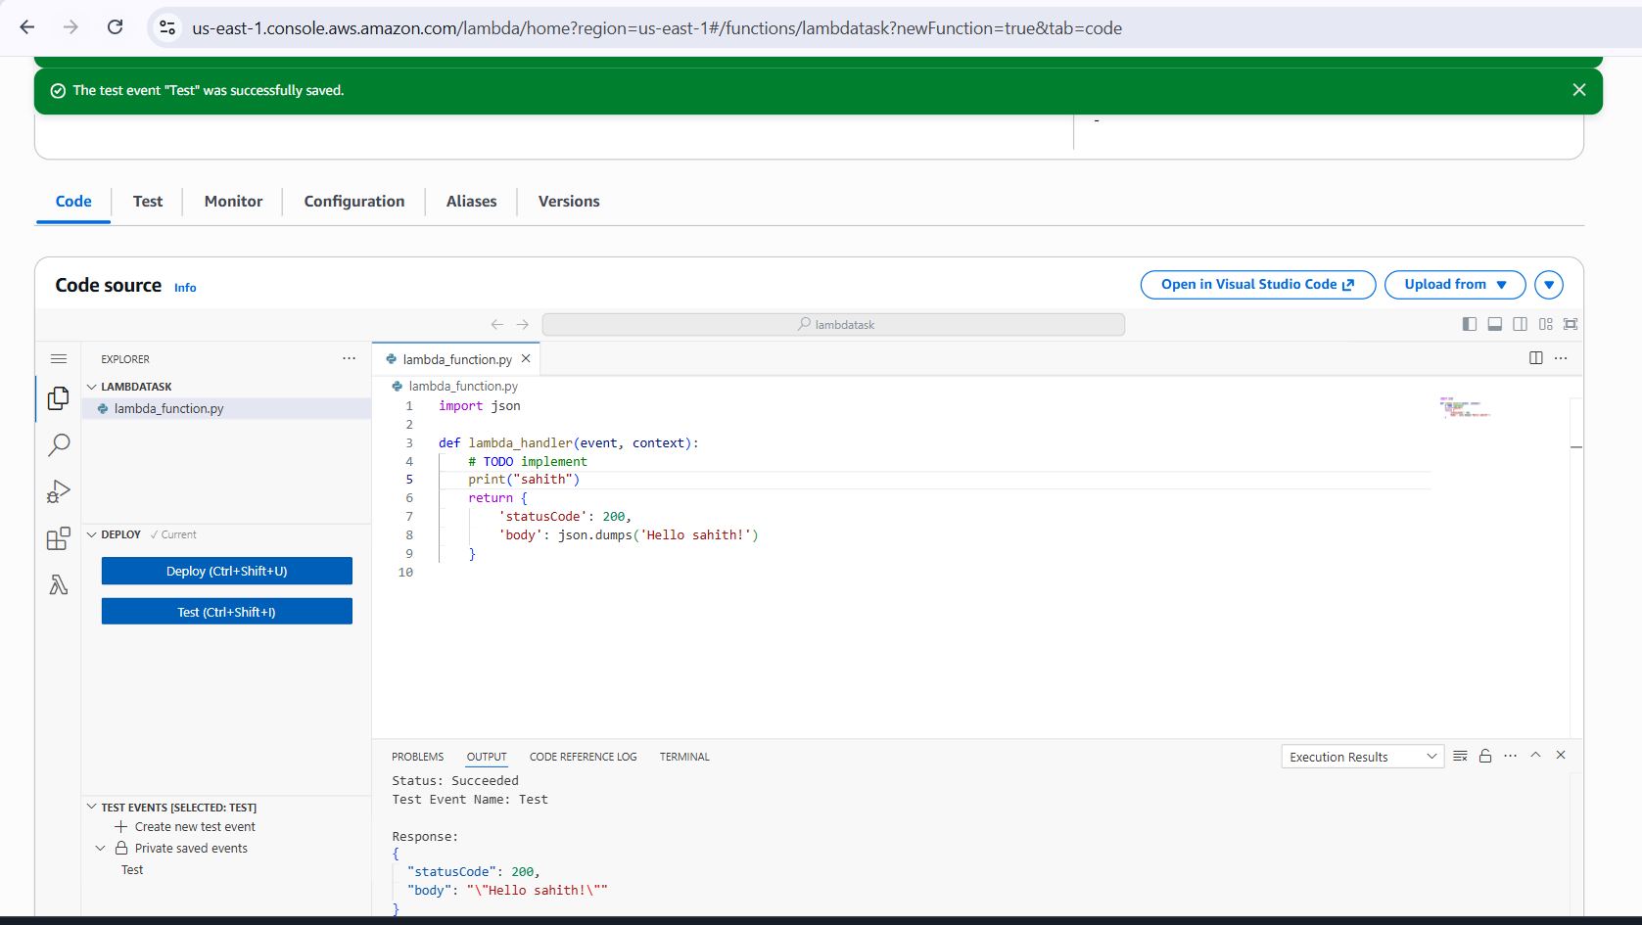
Modify Lambda Function Code
• Navigated to Code tab
• Opened lambda_function.py
• Edited Python handler function
• Added:
• print() statement for logging
• Custom response message
• Updated return body text
Step 13: Deploy Updated Lambda Code
• Clicked Deploy after code modification
• Lambda updated function version internally
• Deployment completed successfully

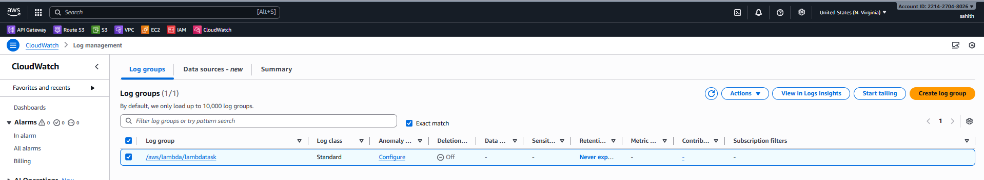
Step 14: Execute Lambda After Code Update
• Ran the saved test event again
• Lambda executed updated code
• Response returned updated message
• Status code remained successful (200)
Step 15: Verify Execution Results
• Verified execution result section
• Confirmed:
• Execution succeeded
• Updated response body
• Execution duration and memory metrics
Step 16: Navigate to Amazon CloudWatch Logs
• Opened CloudWatch service
• Navigated to Log groups
• Located auto-created log group:
• /aws/lambda/lambdatask
Step 17: Inspect Lambda Log Group
• Opened /aws/lambda/lambdatask log group
• Verified:
• Log group creation time
• Retention set to never expire
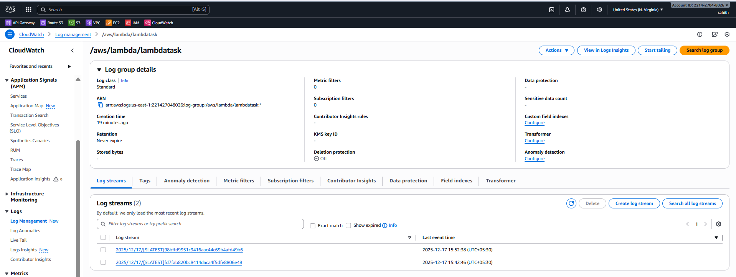

Detailed Steps Performed (AWS Lambda)
Access AWS Lambda Service
• Logged in to the AWS Management Console
• Used the search bar to navigate to AWS Lambda
• Opened the Lambda service dashboard
• Reviewed the Lambda introduction page explaining serverless execution
Initiate Lambda Function Creation
• Clicked on Create a function
• Selected Author from scratch option
• This option allows writing custom Lambda code without templates or containers

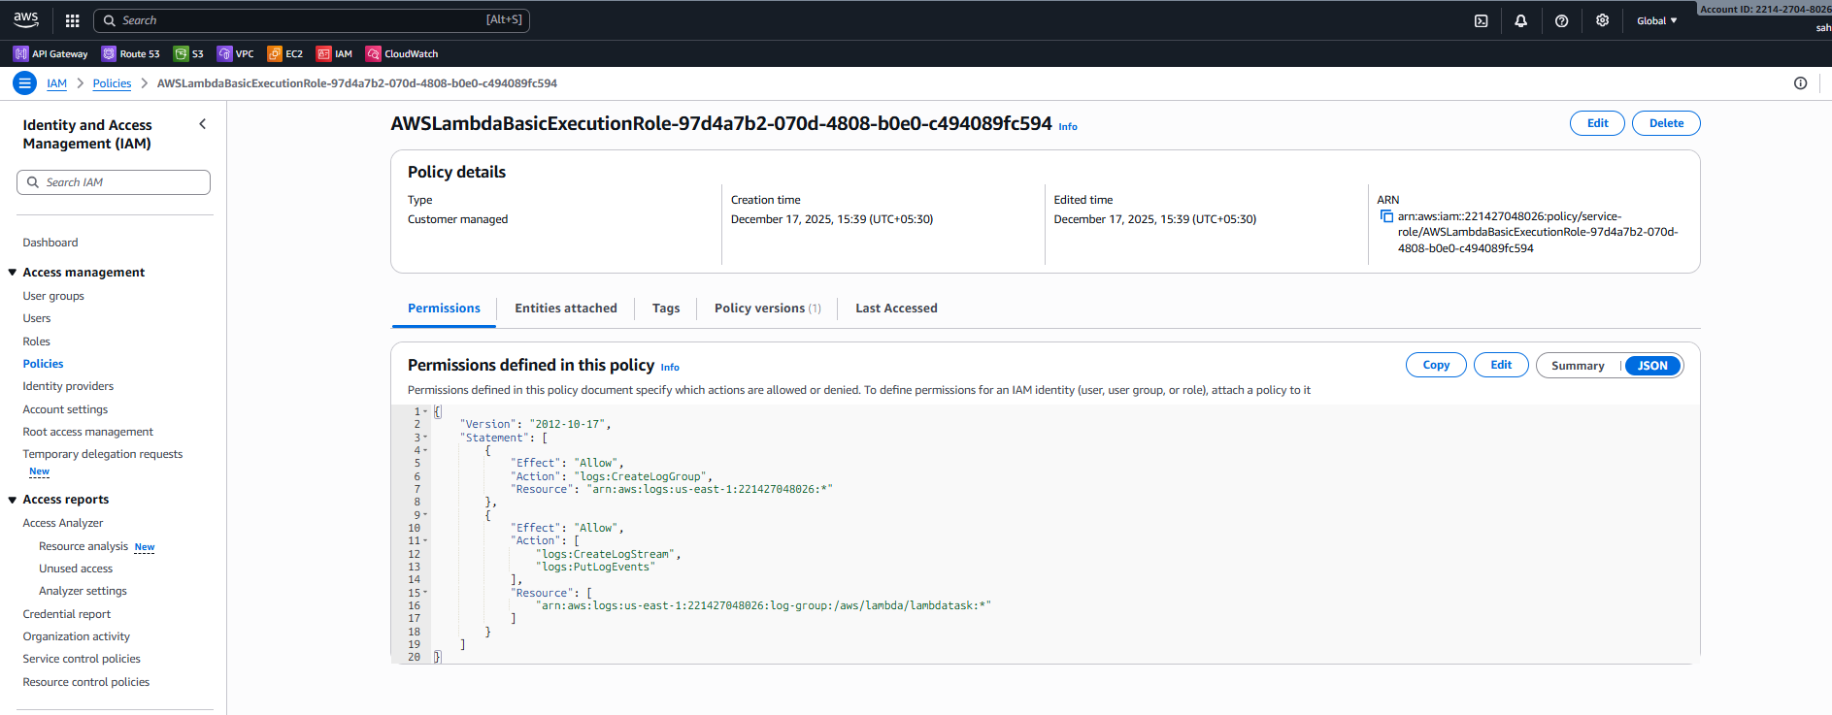

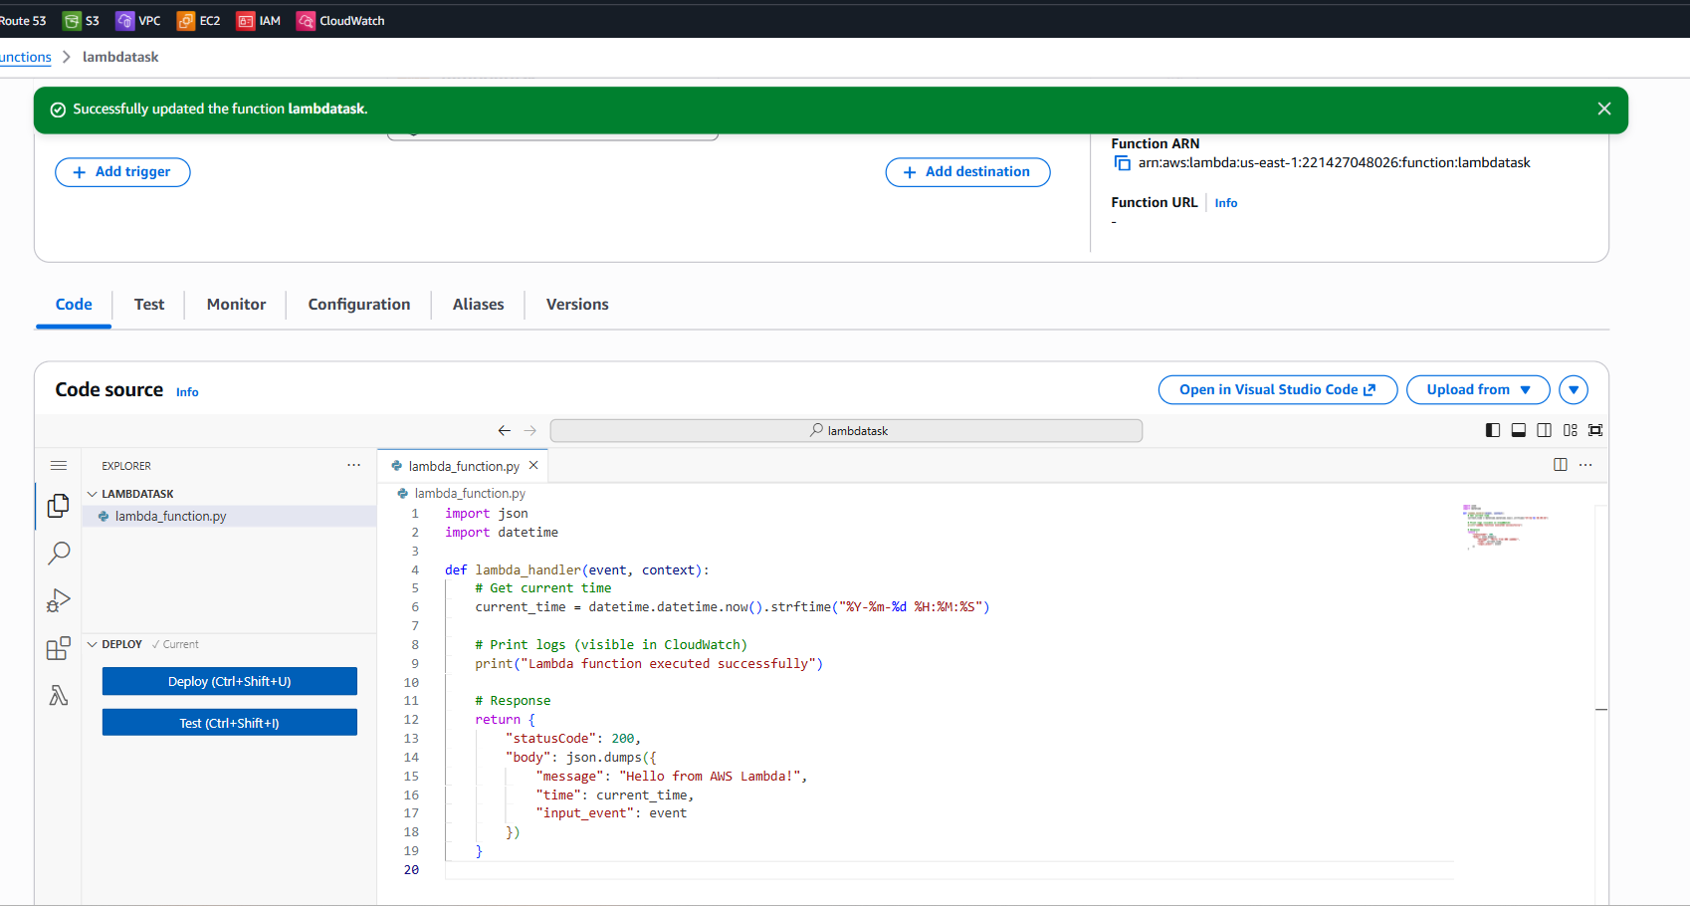
Modify and Deploy Lambda Code
• Edited lambda_function.py in the Code tab
• Added custom log messages using print()
• Enhanced response to include message, timestamp, and input event
• Deployed updated Lambda code
• Re-tested the function and verified updated output
Verify Lambda Logs in CloudWatch
• Navigated to CloudWatch → Log groups
• Opened /aws/lambda/lambdatask
• Verified log streams created for each invocation
• Reviewed execution logs including START, custom logs, END, and REPORT

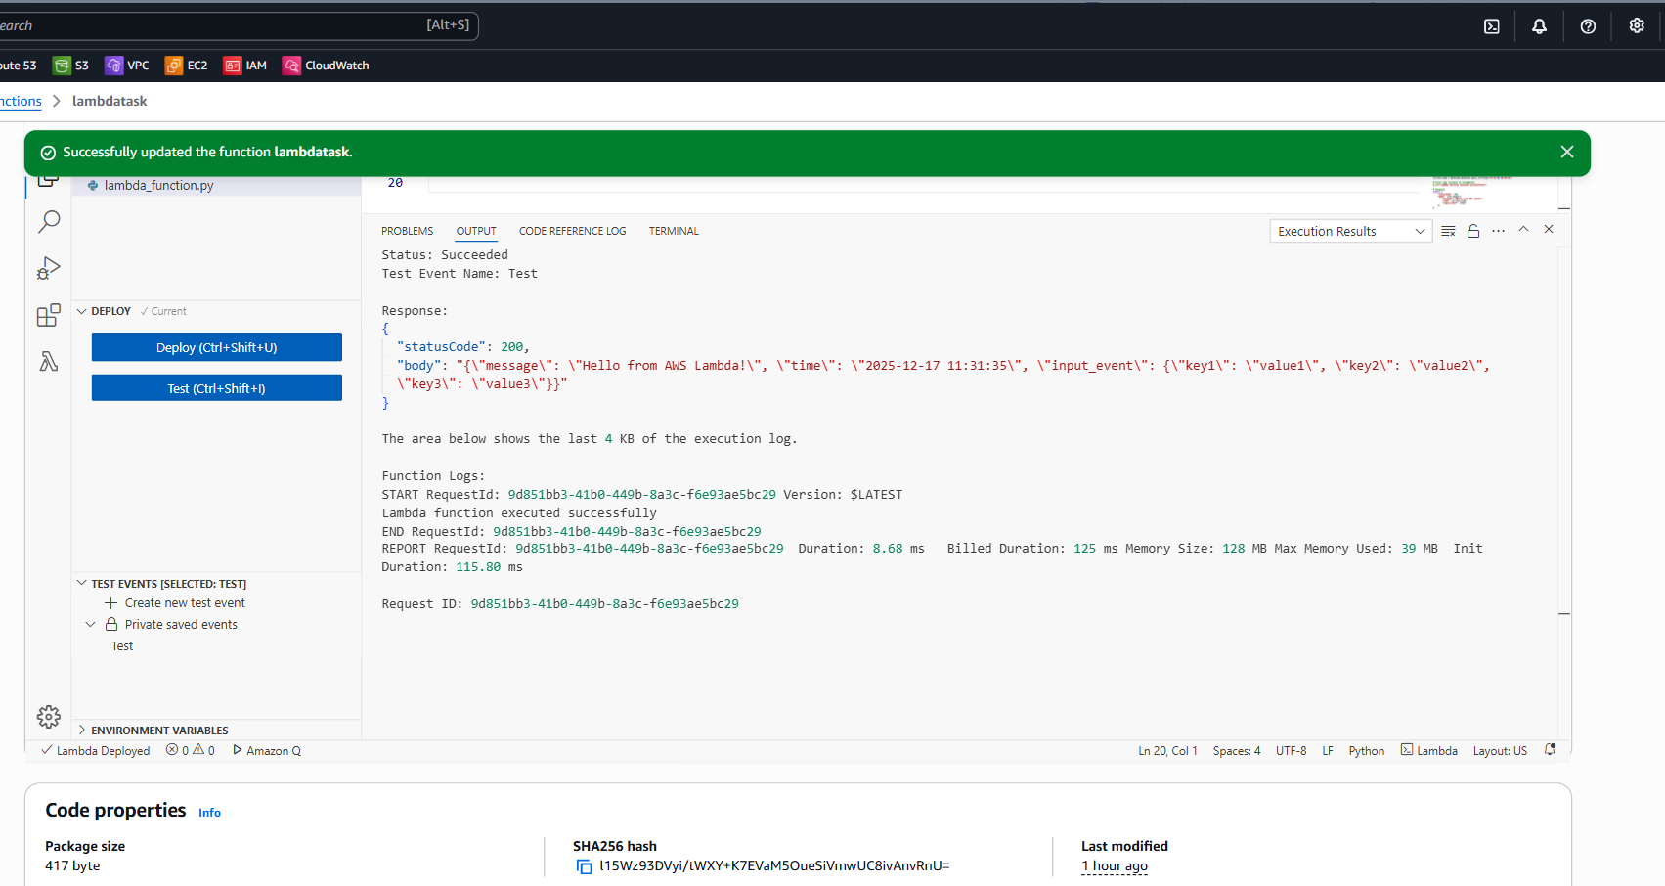
Create S3 Bucket and Upload Objects
• Created an S3 bucket named lambdatasks in us-east-1
• Uploaded objects successfully to the bucket
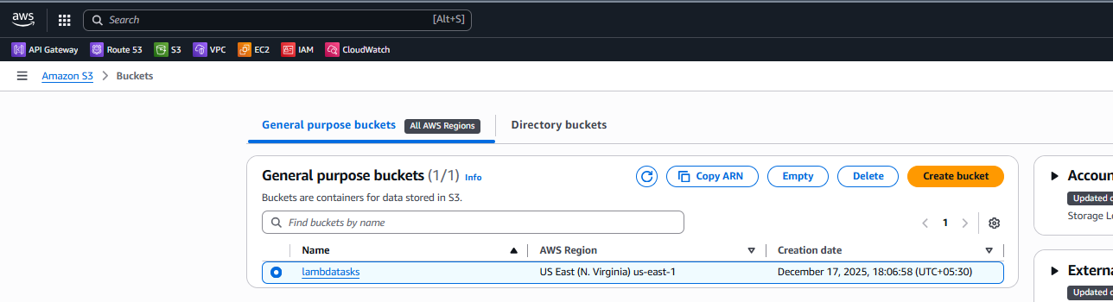
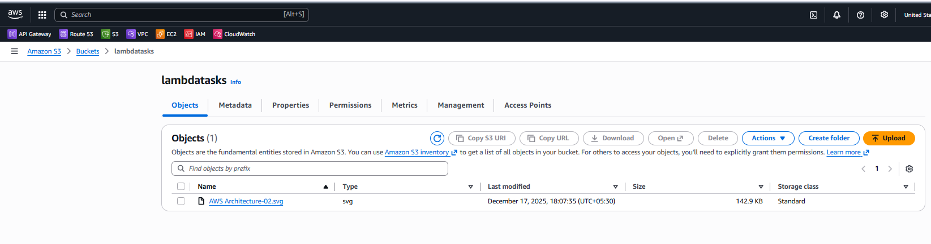
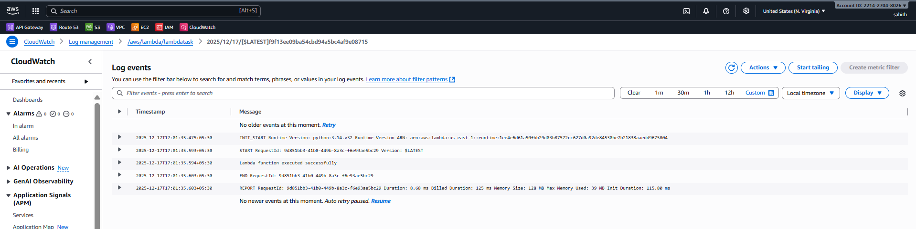
Configure S3 Trigger for Lambda
• Added S3 as a trigger to the Lambda function
• Selected bucket lambdatasks
• Configured trigger for All object create events
• Successfully attached the trigger

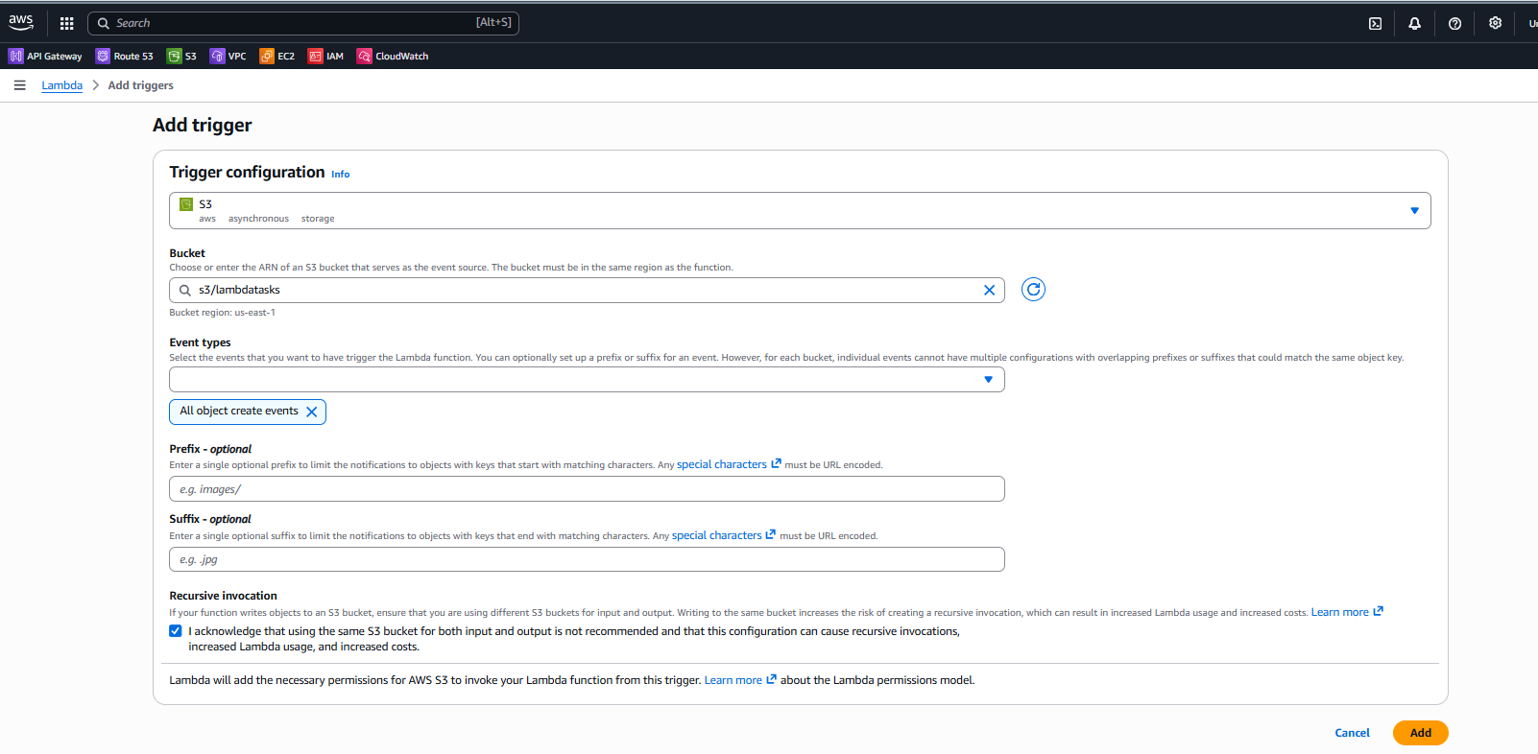
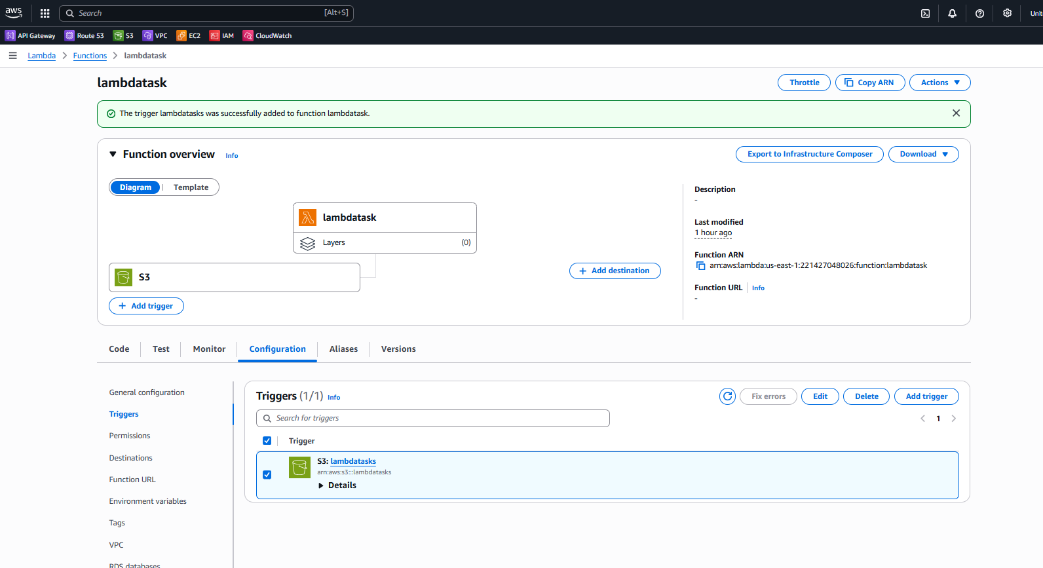
Trigger Lambda via S3 and Validate Logs
• Uploaded a new object to the S3 bucket
• Lambda function invoked automatically
• Verified new log streams in CloudWatch
• Confirmed Lambda received S3 event data and executed successfully
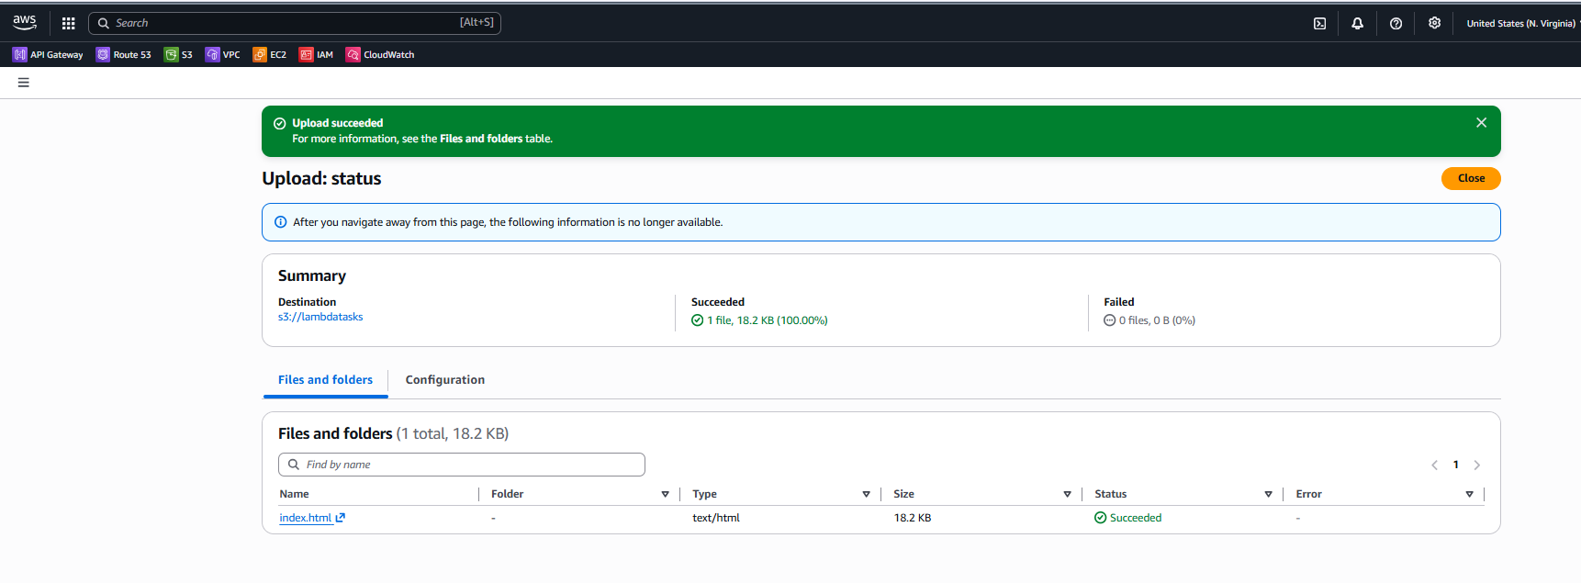
Validate Overall Lambda Workflow
• Lambda executed through manual test and S3 event trigger
• IAM role permissions worked as expected
• Logs were captured automatically in CloudWatch
• Serverless execution achieved without managing infrastructure
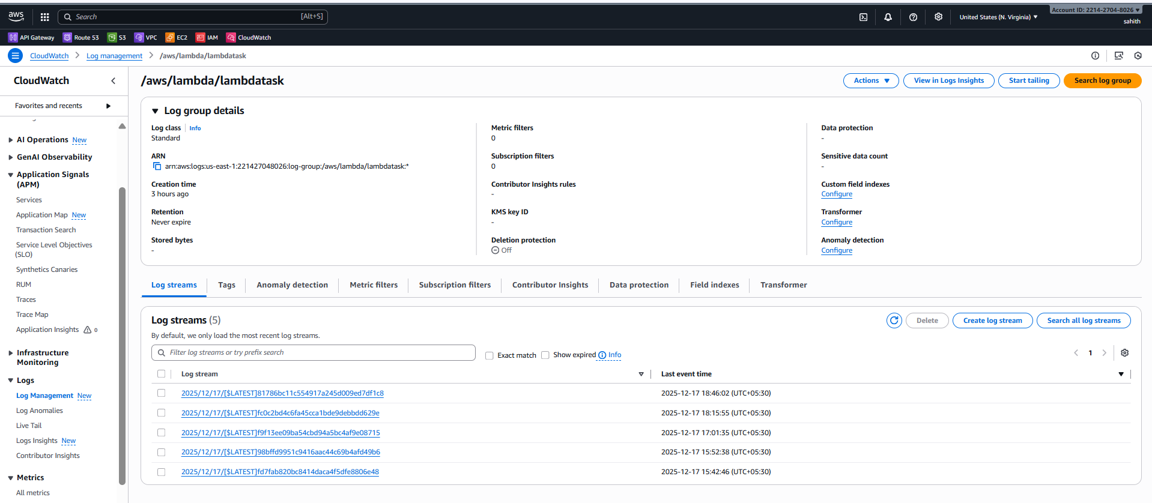
Create and Configure Lambda Function
• Created a Lambda function named lambdatask using Python runtime
• Allowed AWS to create an execution role with CloudWatch log permissions
• Verified function status and ARN
Update Code and Test Lambda
• Modified Lambda code to return a custom response and logs
• Deployed the updated code
• Executed the function using a test event and verified successful output
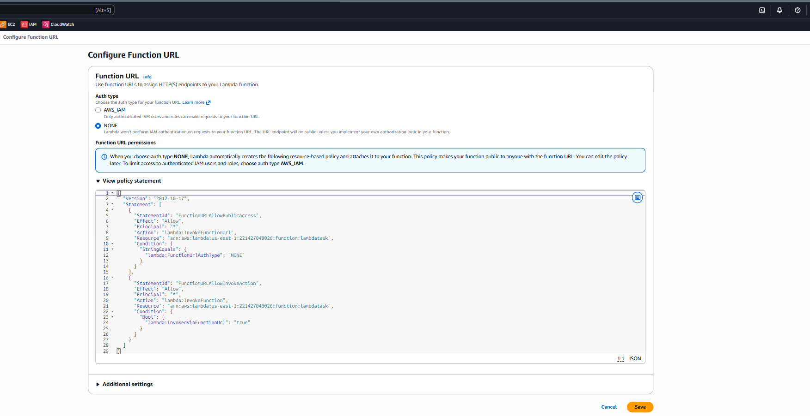
Enable Logging and Monitoring
• Verified automatic log creation in CloudWatch
• Reviewed log streams and execution metrics
Integrate S3 with Lambda
• Created an S3 bucket lambdatasks
• Added S3 trigger for object creation events
• Confirmed Lambda invocation on file upload
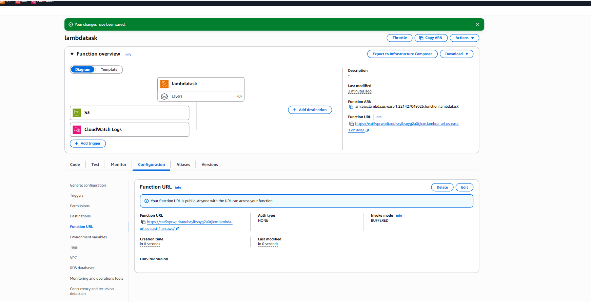
Expose Lambda Using Function URL
• Enabled Function URL with public access
• Accessed the Function URL in a browser
• Verified Lambda execution response
Validate Overall Workflow
• Lambda triggered via test event, S3 upload, and Function URL
• Logs captured automatically without server management

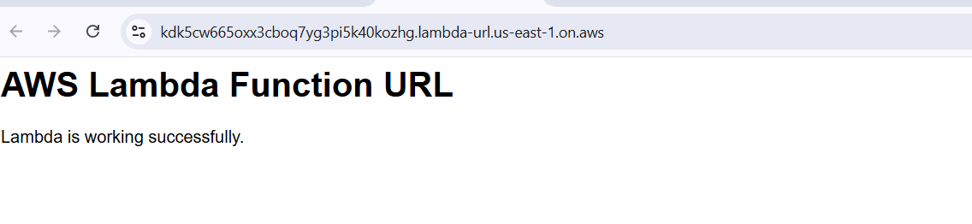
Conclusion:
The AWS Lambda function was successfully created, configured, and tested using multiple invocation methods, including manual test events, S3 object uploads, and a public Function URL. The function executed as expected without requiring server management, demonstrating the effectiveness of a serverless architecture. Integration with Amazon CloudWatch provided real-time logging and monitoring, while IAM roles ensured secure and controlled access. This task validates an end-to-end AWS Lambda workflow suitable for scalable, event-driven applications.

Task Title:
Create and Configure Amazon API Gateway with Lambda Integration
Objective:
To create an HTTP API using Amazon API Gateway, integrate it with an AWS Lambda function, configure routes, deploy the API, and validate access using the invoke URL.
Prerequisites:
• AWS account with API Gateway and Lambda access
• Existing AWS Lambda function (lambdatask)
• IAM permissions to create and manage API Gateway resources
Step-by-Step Implementation:
Access Amazon API Gateway
• Logged in to AWS Management Console
• Navigated to API Gateway
• Viewed API Gateway landing page explaining API creation and management
• Clicked Create an API
Select API Type
• Selected HTTP API as the API type
• Chose HTTP API for lightweight, low-latency Lambda integration
Configure API Details
• Entered API name as Task01
• Selected IP address type IPv4
• Confirmed protocol as HTTP
• Proceeded with default configuration options

Configure Lambda Integration
• Selected integration type as Lambda
• Chose AWS region us-east-1
• Attached existing Lambda function lambdatask
• Verified Lambda integration version 2.0

Configure API Routes
• Created route:
• Method: GET
• Resource path: /hello
• Integration target: lambdatask
• Created another route:
• Method: POST
• Resource path: /process
• Integration target: lambdatask

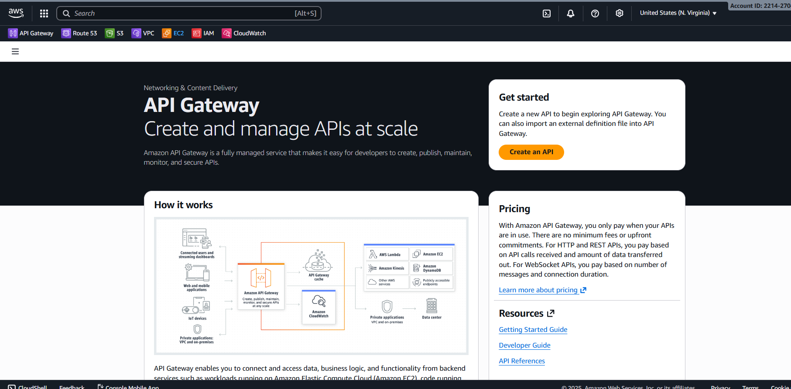
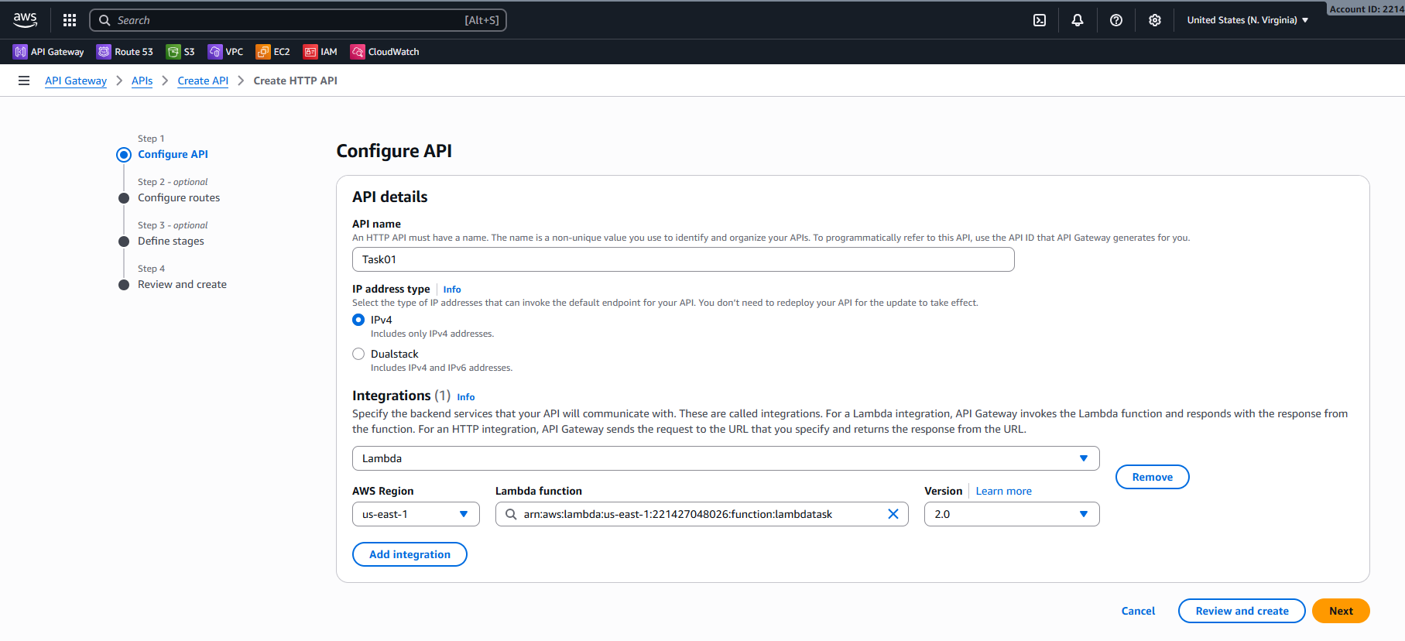
Configure API Routes
• Created route:
• Method: GET
• Resource path: /hello
• Integration target: lambdatask
• Created another route:
• Method: POST
• Resource path: /process
• Integration target: lambdatask
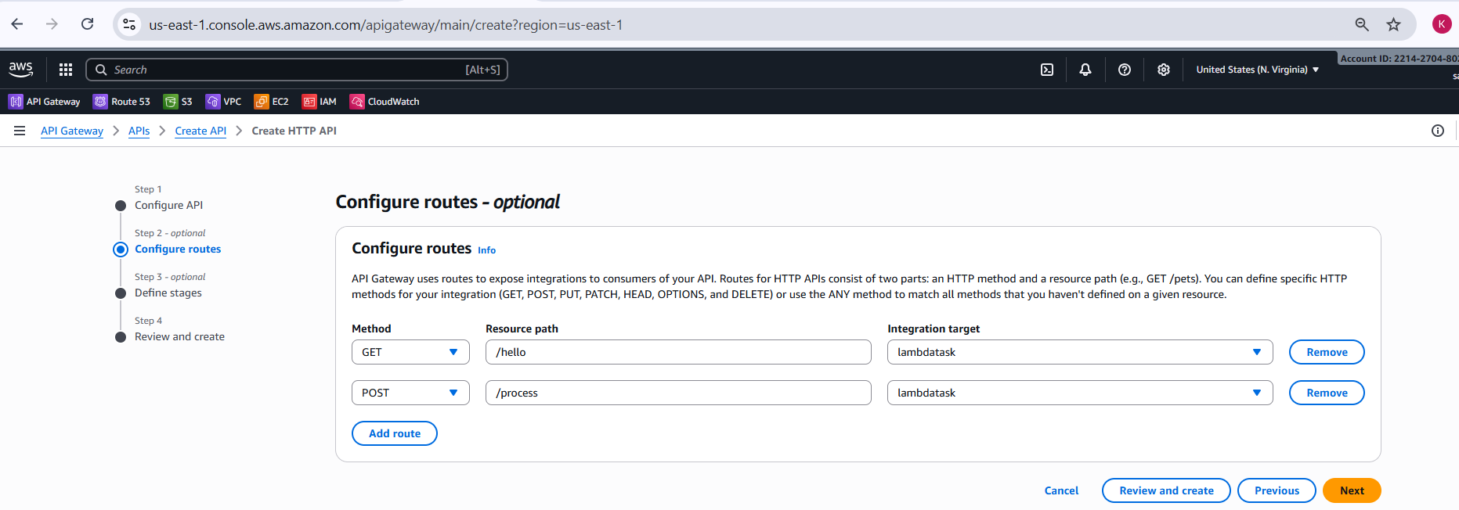
Review and Create API
• Reviewed API name, integration, and routes
• Verified default stage configuration
• Confirmed auto-deploy enabled for the $default stage
• Clicked Create to deploy the API
Verify API Creation
• Confirmed successful API creation message
• Verified API ID and ARN
• Confirmed default endpoint status as Enabled

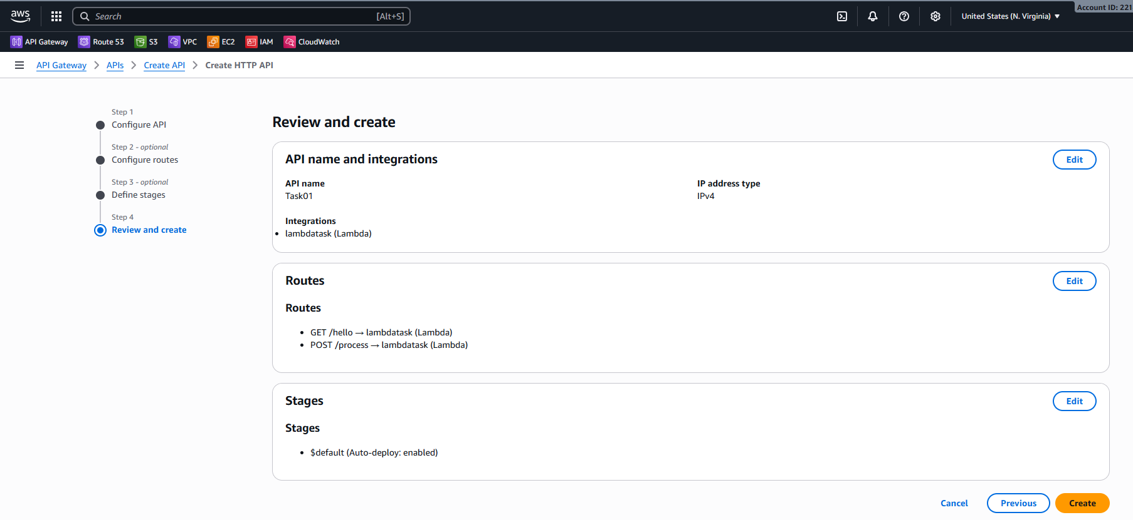
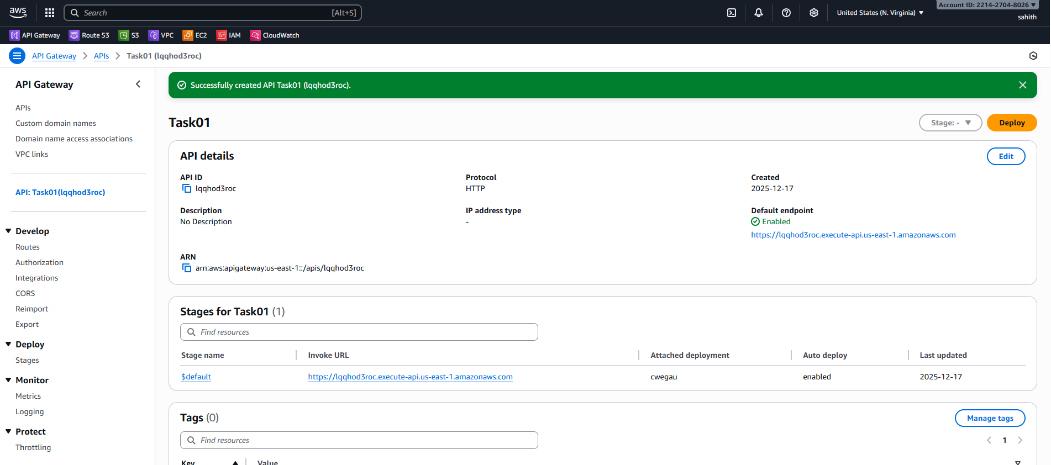
Verify Routes Configuration
• Navigated to Routes section
• Verified available routes:
• GET /hello
• POST /process
• Confirmed both routes are correctly linked to Lambda integration
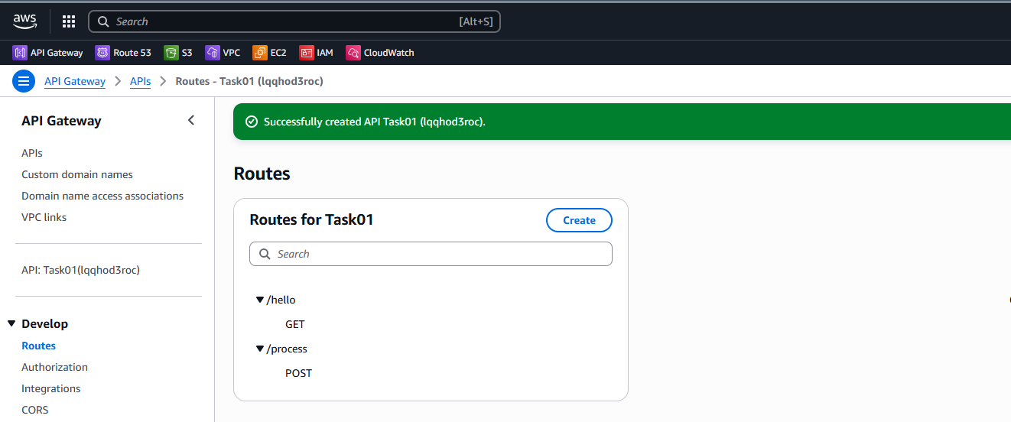
Verify Stage Configuration
• Opened Stages section
• Confirmed $default stage was created automatically
• Verified auto-deploy status was enabled
Test API Using Invoke URL
• Copied the Invoke URL from API details
• Appended /hello resource path
• Accessed the URL using a web browser
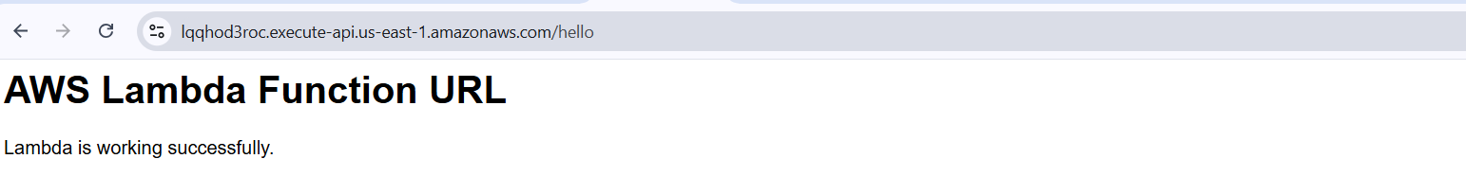
Validate API Response
• API Gateway successfully routed request to Lambda
• Lambda function executed without errors
• Browser displayed response confirming Lambda execution
Validation Steps:
• HTTP API created successfully
• Lambda integration attached correctly
• Routes configured and visible
• Default stage deployed automatically
• Invoke URL accessible and returns Lambda response
Conclusion:
Amazon API Gateway HTTP API was successfully configured and integrated with an AWS Lambda function. Multiple routes were created and deployed using the default stage with auto-deployment enabled. The invoke URL was tested successfully, confirming seamless communication between API Gateway and Lambda, enabling serverless API access.

Overall Tasks Conclusion:
The assignment successfully demonstrated the implementation of a complete serverless architecture using AWS Lambda and Amazon API Gateway. The Lambda function was created, tested, and enhanced with logging and monitoring through CloudWatch. Event-driven invocation was validated using Amazon S3 triggers, and API-based access was enabled through API Gateway with configured routes and stages. The solution confirmed seamless integration between AWS services, efficient execution without server management, and effective monitoring, making it suitable for scalable and real-world serverless applications.

